CLI Chess (beta) User Guide

Starting the program
- Open the folder containing the source files and run index.py
- If you are running windows you may want to replace any instance of os.system(‘clear’) with os.system(‘cls’). There will eventually be a specific windows fork on the program after its published to GitHub.
- You will be presented with a welcome screen with some information about the project and options.
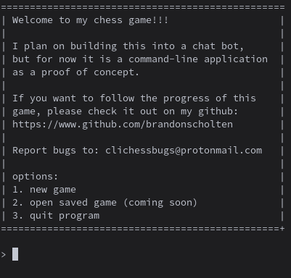

Welcome Screen
- To select an option simply type the number of your option into the prompt and click enter. If you make a mistake the program shouldn’t crash, but just in case all files are enclosed in try catch blocks so that it is literally impossible to break.
- Save game is not yet fully built, so it is impossible to load a game for now.
- To start a new game choose the first option.

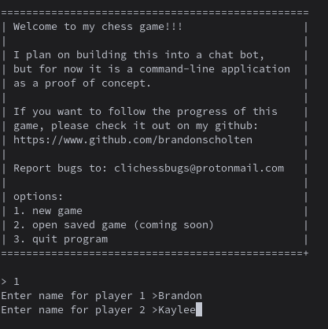
Game Play
- After selecting the new game option you will be prompted to enter names for player one and player two. Online multi-player through the Discord communication platform is the end goal of the project. However, for now it is just a local two player game.
- After player names are entered you will be presented with a text-based chess board.
- Players will be asked in turn for their moves. The board uses the traditional chess layout with columns lettered a through h and rows 1 through 8.
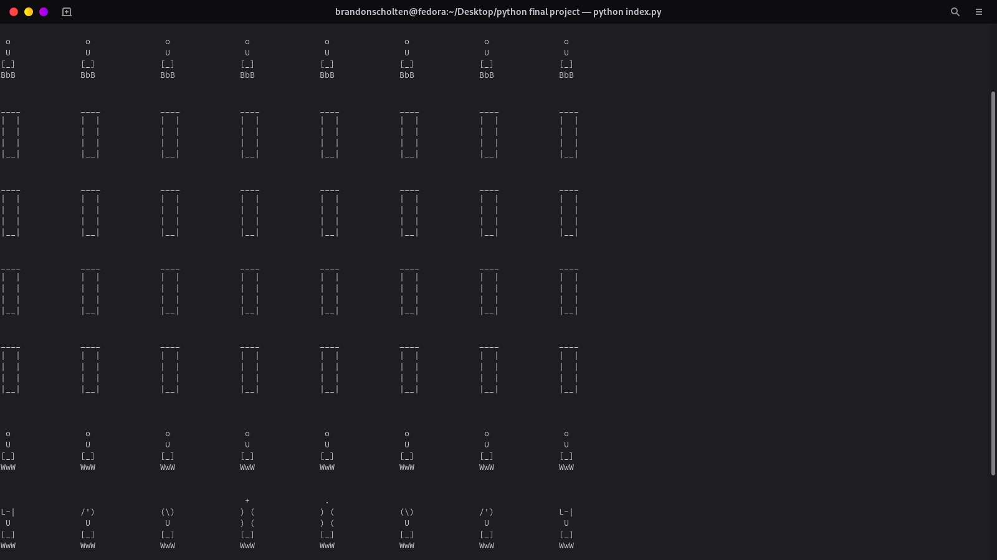
- On your turn, start by entering the location of the piece you would like to move (row and then column). Then enter the location you would like to move the piece. If the move is valid the piece should move. So far the only proven working pieces are pawns, other pieces will often either be considered invalid or cause a fatal error which will end the program. These errors should become less frequent as the game is updated in the future.
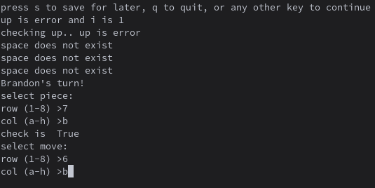
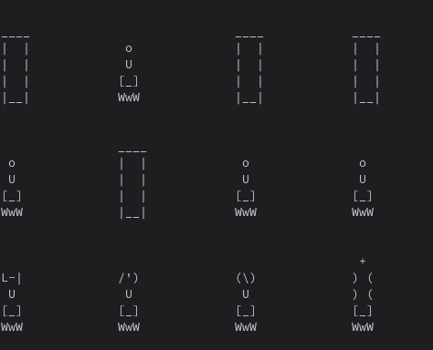
- Note that because this program is still in beta a lot of print statements with information which doesn’t matter to the end user are still present for testing purposes.

